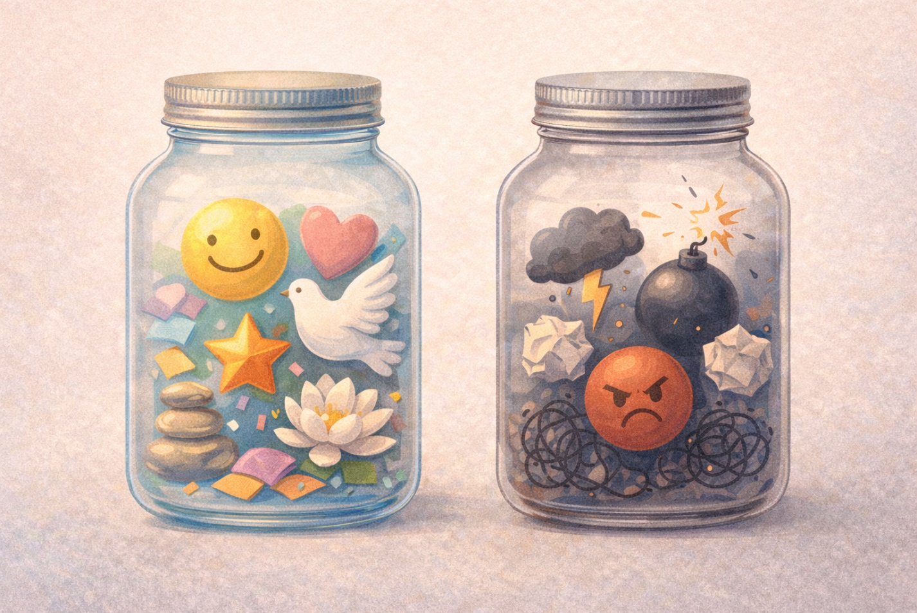
PPS & Service Learning Activity: Sustainability – Gratitude Jars
As part of our Personal and Professional Skills (PPS) and Service Learning classes, we participated in the Gratitude (Glass) Jar Activity, which helped us understand emotional awareness and sustainability of mental well-being. In this activity, the glass jar symbolized our mind and thinking processes, while the objects placed inside represented different emotional states we experience in daily life.
When we added positive emotions such as happiness, calmness, gratitude, and confidence into the jar, it appeared balanced and visually pleasing. This demonstrated how positive emotions contribute to emotional stability and a healthy mindset. It helped us understand that pleasant experiences and positive thinking play a vital role in maintaining inner peace and improving our ability to learn, collaborate, and perform effectively.
In contrast, when negative emotions such as stress, anger, pressure, and sadness were added, the jar appeared overcrowded and disorganized. This represented how excessive negative emotions can overwhelm the mind and disturb emotional balance. Through this visual and hands-on experience, we understood how unmanaged emotions can affect decision-making, focus, and overall well-being.
The activity emphasized the importance of emotional management and self-reflection, both of which are key components of PPS. It encouraged us to recognize our emotions, understand their impact, and consciously work towards developing positive emotional habits. By relating emotions to sustainability, the activity highlighted that maintaining emotional balance is essential not only for personal happiness but also for long-term personal and academic growth.
Overall, the Gratitude Jar activity provided a simple yet powerful model to understand how emotional awareness and positivity can enhance our mental resilience, learning capacity, and ability to contribute meaningfully to our community.

